# SIIM-FISABIO-RSNA COVID-19 Detection

Problem statement formation:

Working with imaging data and annotations from a group of radiologists, can we identify and localize COVID-19 abnormalities in an efficient and quick way?

Context:

Five times more deadly than the flu, COVID-19 causes significant morbidity and mortality. COVID-19 looks very similar to other viral and bacterial pneumonias on chest radiographs, which makes it difficult to diagnose. It can be diagnosed via polymerase chain reaction to detect genetic material from the virus or chest radiograph. However, it can take a few hours and sometimes days before the molecular test results are back. By contrast, chest radiographs can be obtained in minutes. We want to help radiologists diagnose millions of COVID-19 patients more confidently and quickly using the chest radiographs. This will also enable doctors to see the extent of the disease and help them make decisions regarding treatment. Therefore, we are trying to develop a computer vision model to identify and localize COVID-19 abnormalities in an efficient and quick way.

Criteria for success:

Achieving at least 90% accuracy and 0.80 f1-score.

Scope of solution space:

Try different object detection models, like Vgg or Resnet model, to identify the COVID-19 image. Find the one that has the highest f1-score.

Constraints:

1. Data limited. There are only 6334 images in the training dataset. We may need more data to increase the accuracy.
2. Class imbalance. Here is the class information:

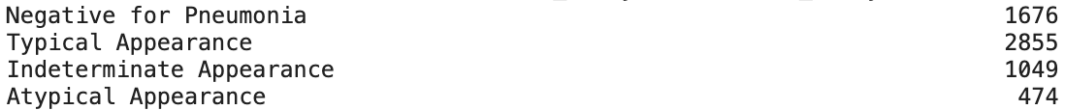

Stakeholders:

FISABIO, The Foundation for the Promotion of Health and Biomedical Research of Valencia Region

Data Sources:

Radiological Society of North America (RSNA)

Reference: [A Gentle Introduction to Object Recognition With Deep Learning](https://machinelearningmastery.com/object-recognition-with-deep-learning/)

[Object Detection in 2021: The Definitive Guide](https://viso.ai/deep-learning/object-detection/)